**LinkedInsights Design Choices**

Avril Mauro, Dennis Ho, Esther Ho

Website Link:

<https://avrilmauro.github.io/LinkedInsights/index.html>

## 

## **U.S. Job Market Map: Salary, Sector, and Skills by State and County (2023–2024)**

We implemented toggle functionality between state and county granularity to give users control over their data exploration experience. Distinct color palettes (plasma for counties and viridis for states) were chosen for their strong contrast properties, with adjusted thresholds to accommodate the wider salary ranges at county level. We reduced layer opacity to allow simultaneous visibility of both layers, enhancing data comparison. Zoom interaction was deliberately restricted to keep users focused on relevant U.S. territories, preventing disorientation. Information density was carefully managed through simplified tooltips showing only essential data initially, with comprehensive details available on demand through pop-ups to prevent cognitive overload. We selected Folium for its robust interactive elements and chose the subtle CartoDB background specifically to minimize visual distraction while maintaining necessary geographical context through borders and major city markers.

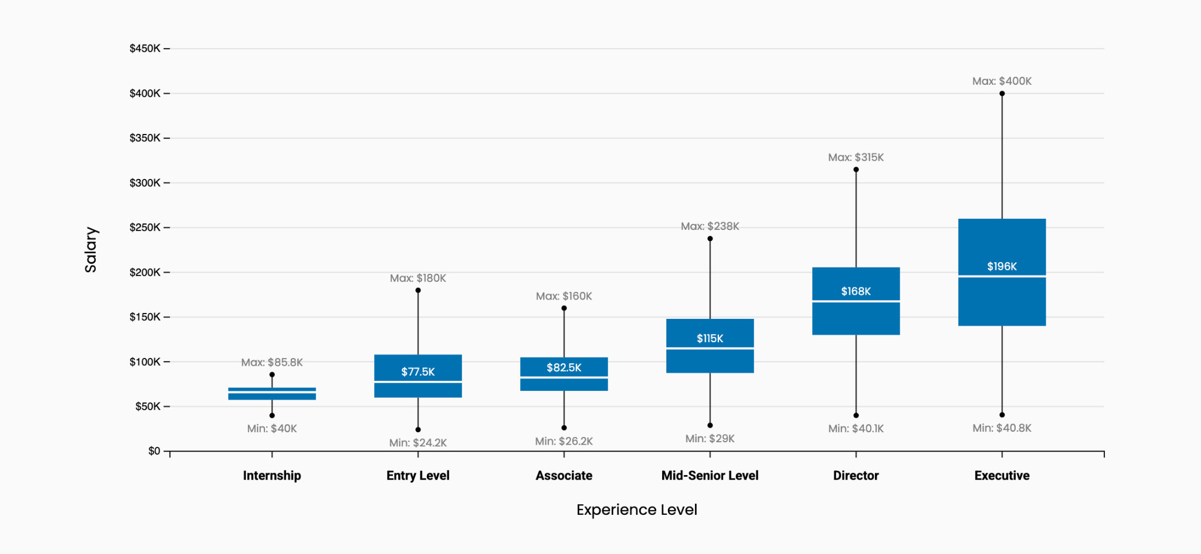

## **U.S. Job Market Box Plot: Salary Distributions Across Experience Levels (2023-2024)**

We maintained visual consistency with the website by using the same blue (#0072b1) for the boxes, creating brand cohesion throughout the user experience. The slightly off-white background was chosen to enhance contrast and improve median line visibility, making key statistics more immediately apparent. We limited grid lines to horizontal only and used subdued styling to create reference points without competing with the primary data elements. Min/max values were deliberately labeled in grey to create a visual hierarchy that emphasizes median values, the most statistically significant data point. We added endpoint dots to provide clear visual indicators of range boundaries, enhancing data comprehension. Experience levels were arranged in logical career progression to create an intuitive narrative about salary evolution. Dollar value formatting was standardized with appropriate rounding to simplify number recognition while maintaining necessary precision through decimal places for smaller amounts.

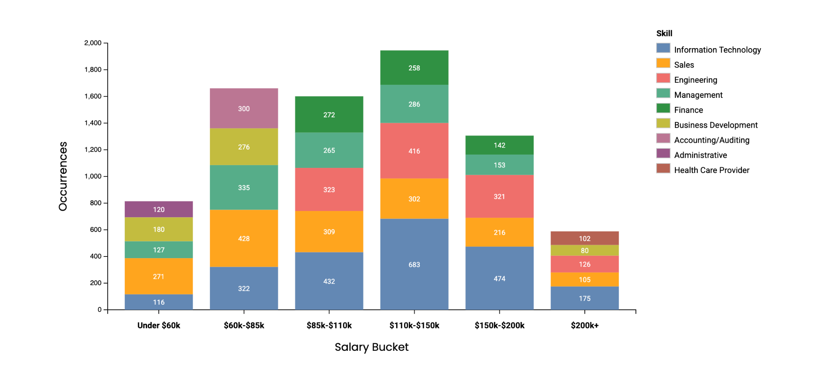

## **U.S. Job Market Bar Plot: Top 5 Skills Across Salary Ranges (2023-2024)**

We standardized dollar value formatting with "k" notation to improve readability while preserving space efficiency. White data labels were embedded within each category to provide immediate value recognition without requiring eye movement to a legend or axis. We selected distinct colors for each skill category specifically to enhance categorical differentiation for both general readability and accessibility for users with color vision deficiencies. The legend was intentionally positioned outside the chart area to prevent visual clutter while maintaining reference availability. Y-axis labels were formatted with commas for values exceeding 1,000 to improve numerical comprehension at a glance. We widened the bars to maximize data density within the available space, reducing unnecessary white space. Categories were strategically ordered with the highest occurrence counts at the bottom to create a visual foundation of the most important skills, establishing a clear data hierarchy that guides user attention to predominant market trends.

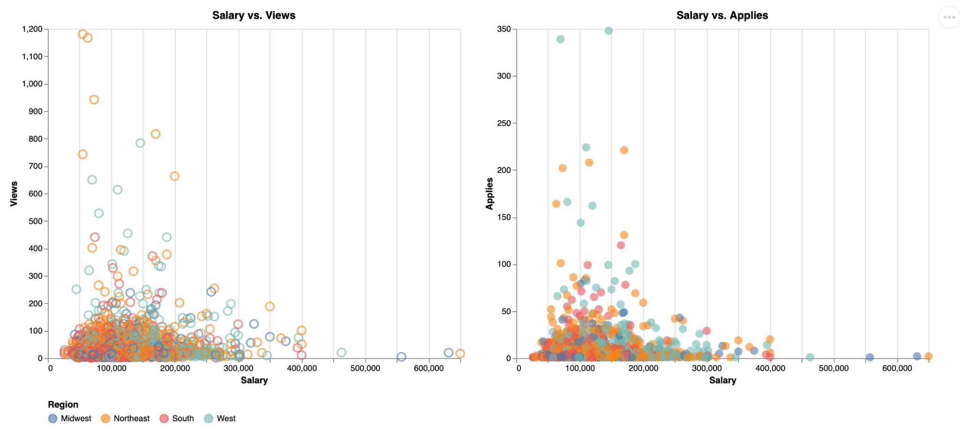

## **U.S. Job Market Scatter Plot: Job Impressions by Salary and Region (2023-2024)**

We differentiated between Views and Applies metrics through distinct mark types to create immediate visual separation between these related but different data series. Region-based color coding was implemented to enable focused analysis through interactive filtering, allowing users to isolate geographic patterns. We chose to use only vertical grid lines with subtle styling to provide reference points for salary values without creating visual noise that would compete with the data points. Numerical formatting with comma separators was applied for improved readability of larger values. Interactive tooltips were integrated to provide detailed job and salary information on demand, maintaining a clean visualization while enabling deeper data exploration. We selected visually distinct colors for each region to ensure clear differentiation between geographic segments, allowing users to quickly identify regional patterns in job market activity.

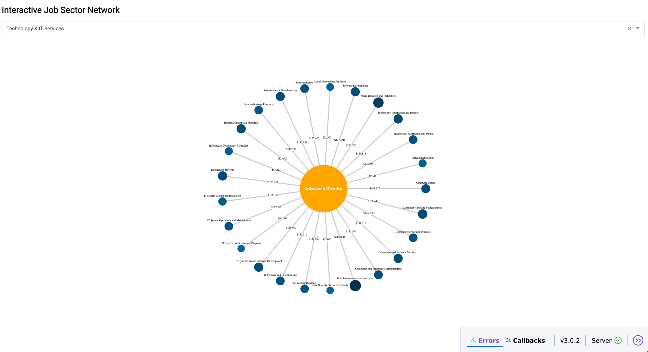

## **U.S. Interactive Job Sector Network (2023–2024)**

We implemented interactive filtering by sector to manage visual complexity, preventing cognitive overload when dealing with the extensive dataset of sectors and industries. Website color consistency was maintained by using the established blue (#0072b1) for industry nodes, creating brand cohesion while leveraging shade variations to encode salary information, making higher-earning industries immediately identifiable. Node sizing was correlated with salary values but carefully scaled to preserve the star graph layout, preventing distortion of the overall structure. We chose a star configuration specifically to illustrate the hierarchical relationship between industries and their parent sector. The central sector node features the website's standard yellow to create visual anchoring through contrast against the blue industry nodes. Relationship lines were annotated with salary figures to provide explicit quantitative context to the connections, enhancing data transparency and enabling more informed comparisons between industry segments.